**Create a project on a fun game where system will give you answer of your all questions using python**

Note :

* Allow the user to input their question.
* Show in progress message.
* Create 10/20 responses, and show a random response.
* Allow the user to ask another question/advice or quit the game.

Flow chart :-

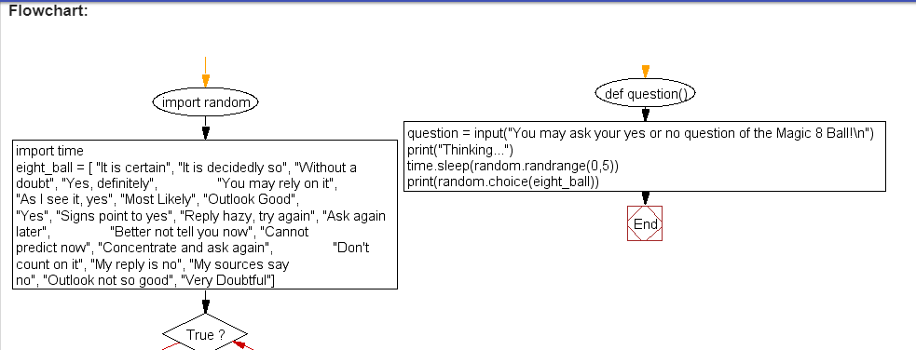

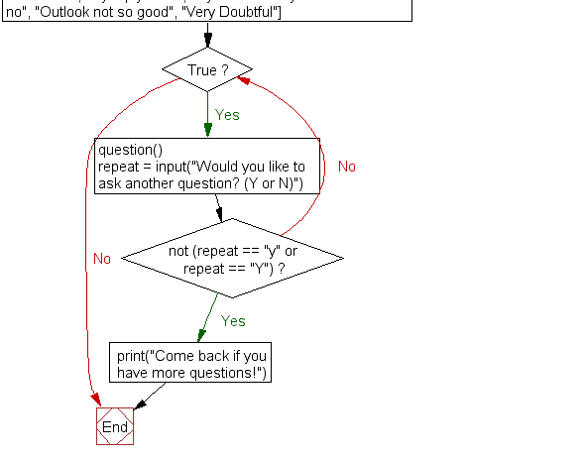

***CODE:-***

**import random**

**import time**

**eight_ball = [ "It is certain", "It is decidedly so", "Without a doubt", "Yes, definitely",**

**"You may rely on it", "As I see it, yes", "Most Likely", "Outlook Good",**

**"Yes", "Signs point to yes", "Reply hazy, try again", "Ask again later",**

**"Better not tell you now", "Cannot predict now", "Concentrate and ask again",**

**"Don't count on it", "My reply is no", "My sources say no", "Outlook not so good", "Very Doubtful"]**

**def question():**

**question = input("You may ask your yes or no question of the Magic 8 Ball!\n")**

**print("Thinking...")**

**time.sleep(random.randrange(0,5))**

**print(random.choice(eight_ball))**

**while True:**

**question()**

**repeat = input("Would you like to ask another question? (Y or N)")**

**if not (repeat == "y" or repeat == "Y"):**

**print("Come back if you have more questions!")**

**break**

out_put:-

n [5]: runfile('D:/maagic.py', wdir='D:')

You may ask your yes or no question of the Magic 8 Ball!

what is my name

Thinking...

Yes

Would you like to ask another question? (Y or N)y

You may ask your yes or no question of the Magic 8 Ball!

are you ok?

Thinking...

Without a doubt

Would you like to ask another question? (Y or N)

